.FORTH Lecturer
INCREASING N USE EFFEICIENCY
Since fertilizer N efficiency is determined by the biomass yield and
N – Uptake by acrop , all factors that affect biomass yield and N concentration in tissue will affect N use efficiency .
These factors can be classified into :
1-Soil factors
* Initial fertility – very fertile soils give lower fertilizer N response
** texture and stracture – more leaching occurs in light , sandy soil
*** PH , salinity / alkalinity – greater ammonia volatization occurs
In calcareous and alkaline soils
**** topography – surface runoff losses are greatest from upper
Topographic regions
***** drainage – poor drainage can lead to large denitrification losses
2- crop factors
- Choice of crop ( where more than one crop can be grown)
Its yield potential ( N uptake potential )
** choice of crop variety , its growth periods , yield potential
And efficiency of nutrient utilization
*** resistance of variety to diseases and pests , drought and other stress factors
**** resistance of crop variety to soil problems such as water , logging , salinity , alkalinity , ,nutrient toxicities
3- Environmental factors
- Rainfall and its distribution – large rain can lead to severe runoff
And leaching losses
** sunny days and sunshine hour day length , heat ---
4- agronomic practices
*Timely sowing – delays can reduce yield
** adequate plant population
*** water management – water efficient irrigation practices
In irrigated areas , water conversation practice for dryland conditions

5- fertilizer management
- Rate of application matched to crop needs

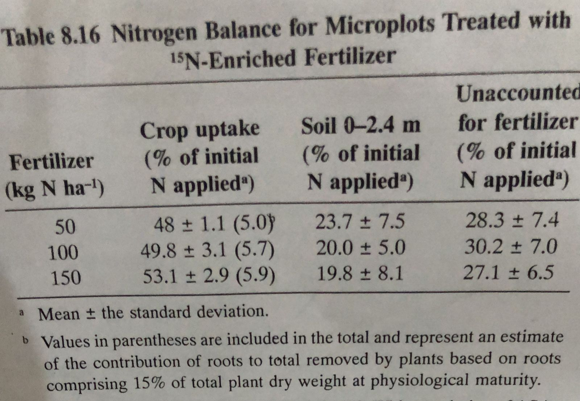

- Method of application to reduce nutrient losses

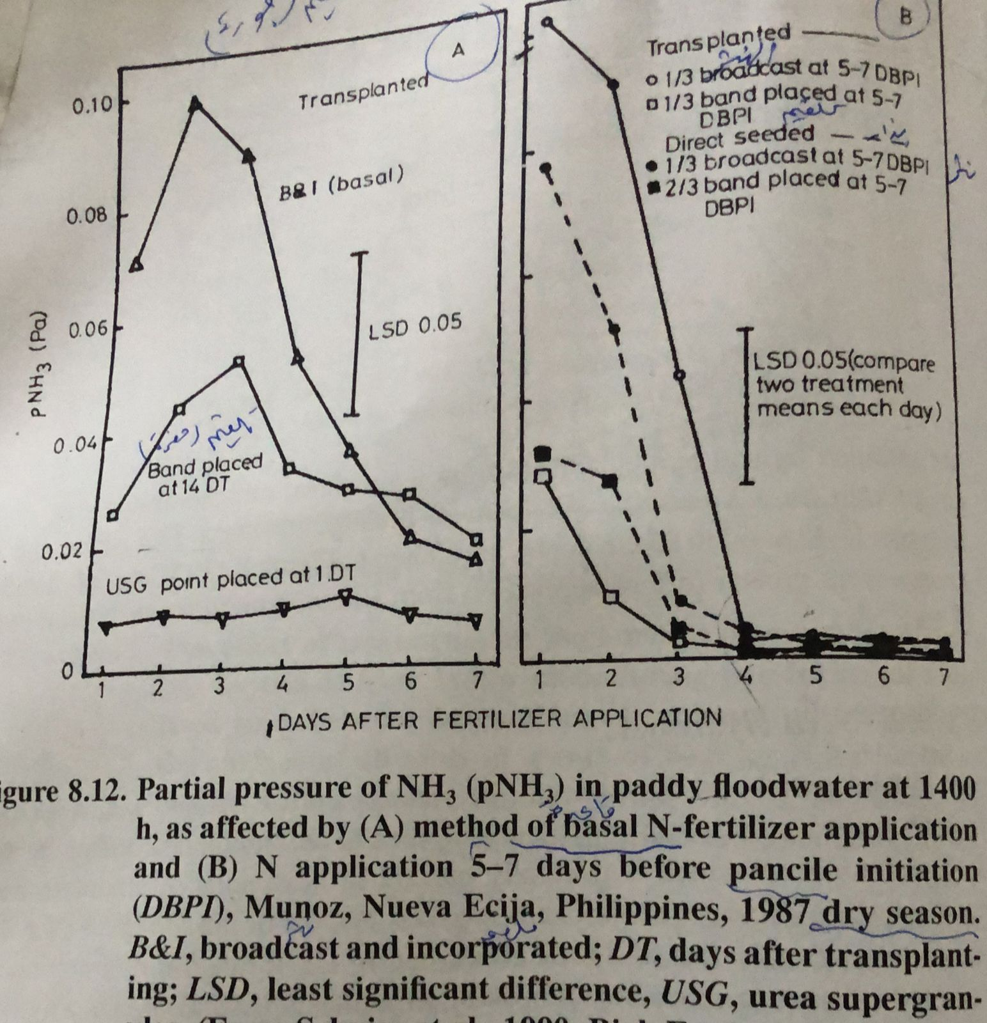
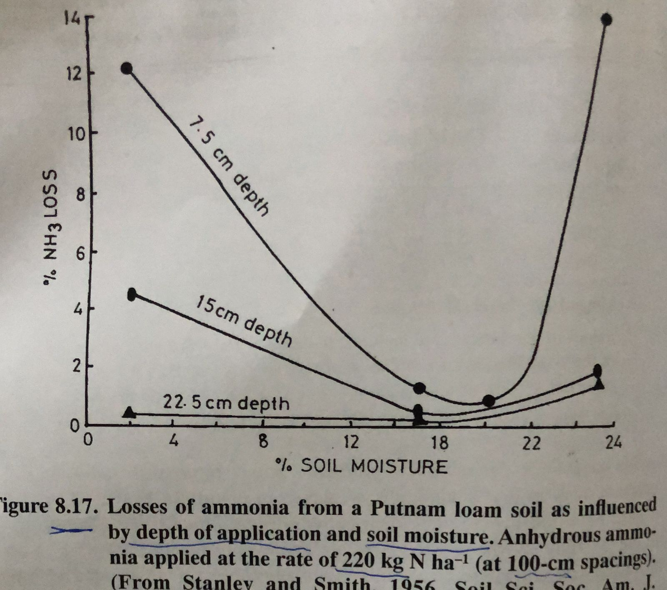

- Time of application matched to crop nutrient uptake
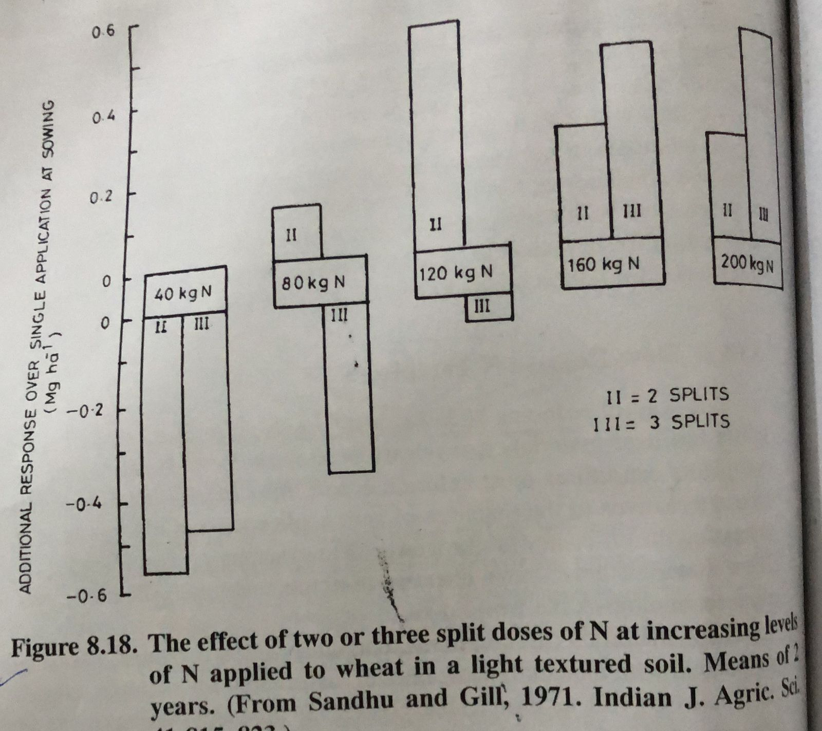

- Source of N- modified urea materials , NH4/NO3 ratio , liquid
- Fertilizer amendments – nutrification and urease inhibitors , coatings

Nitrification inhibitors
Since leaching and denitrification losses of fertilizer N take place Only after ammonium or ammonium – producing fertilizers are nitrified , retarding the Nitrification rate has been considered one way to reduce N Losses then increase N- efficiency

NOTE ,
N - fertilizer is maintained primarily in the ammonium ( non leaching ) Form for several weeks until plant growth and N uptake rates increase to extent that much of nitrate formed is used immediately And nitrates do not accumulate in soil .

Fifth Lecture
Nitrification inhibitors (NIS)
As a group of agrochemical with development of N-serve or nitrapyrin ( 2- chloro-6 pyridine )
Since , large number of chemicals have been reported as NIS , but only seven have been produced commercially , AM( 2-amino -4- chloro -6 methyl pyrimidine) , DCD ( Dicyandiamide ) , ST( 2- sulfanilamide thiozole), thiourea , ferrozole , MBT(2- mercaptobenzothiazole )
One natural product , namely , neem (seed extract )
Slow -release N fertilizers
Sulfure -coated urea

